Life Management 2.0 (Android Version)

User Manual

Authors: Lazaro Fernandez,

Natalia Filippova

**Guest**

1- Guest navigates the landing page screen and clicks the next arrow to continue.

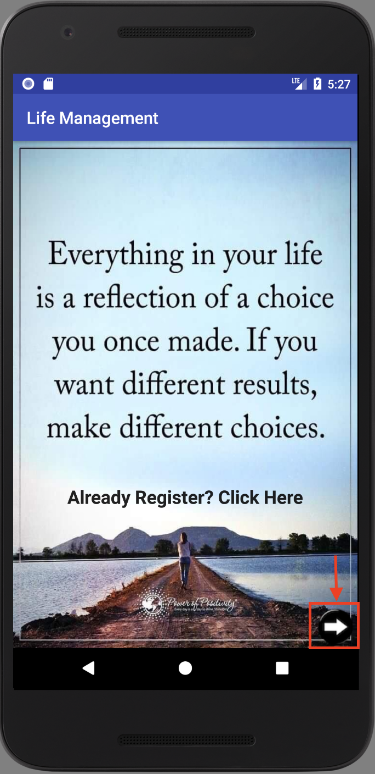

2- Inform the guest the 6 basic needs of Life. He/She can click on each need as follows.

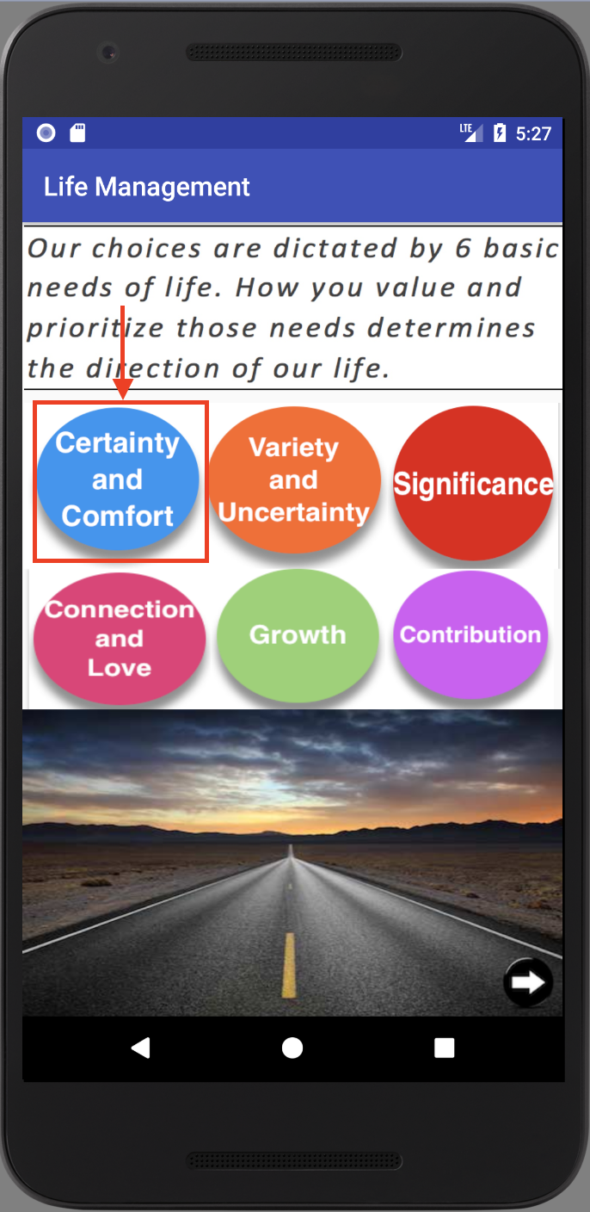

3- Information about the need Certainty and Comfort.

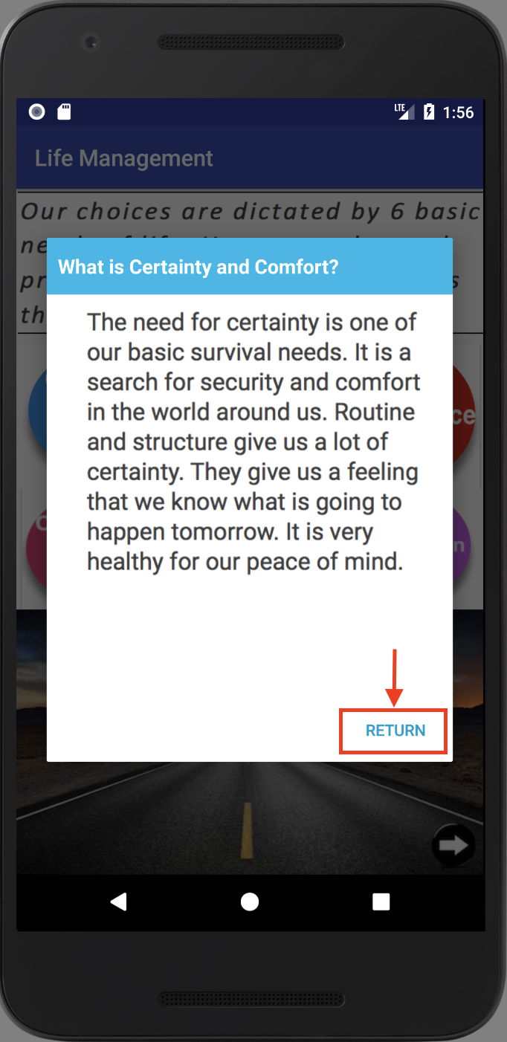

4- Guest clicks on Variety and Uncertainty need.

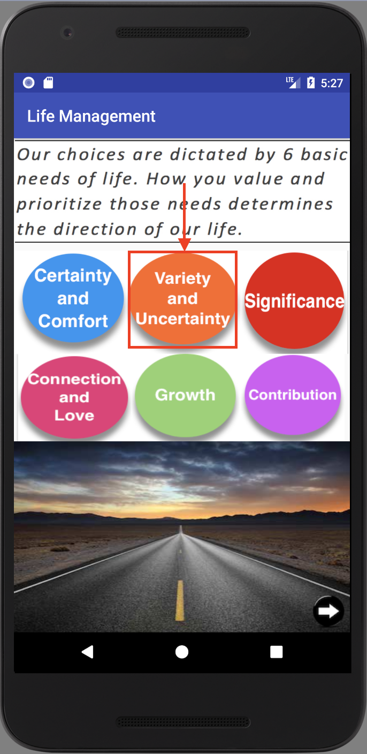

5- After reading that need, they can go back to previous screen.

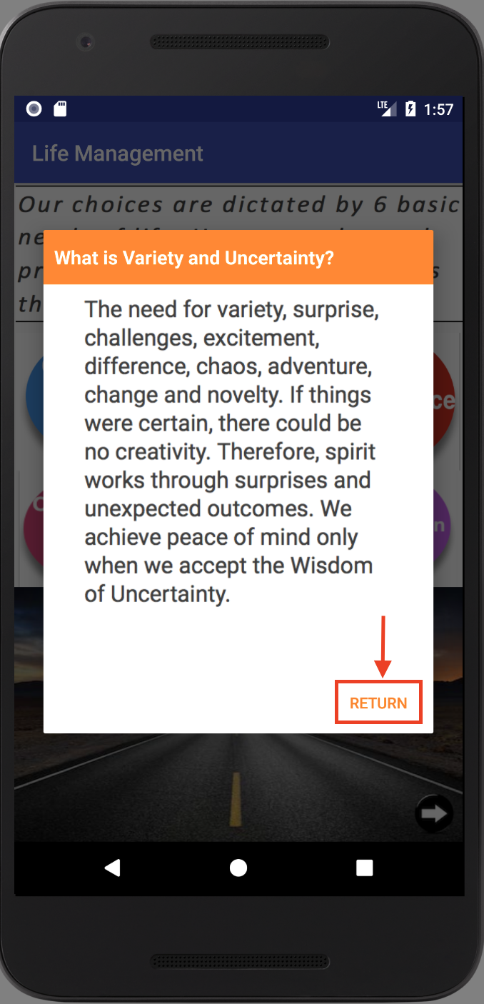

6- Guest clicks on Significance need.

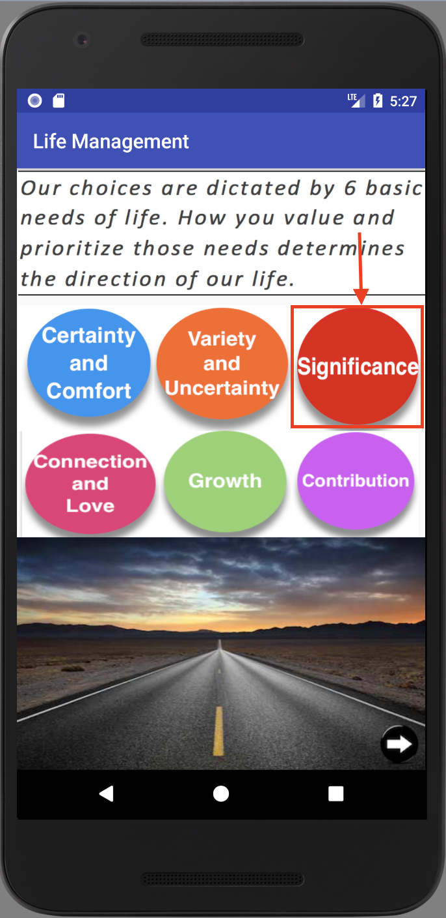

7- After reading that need, they can go back to previous screen.

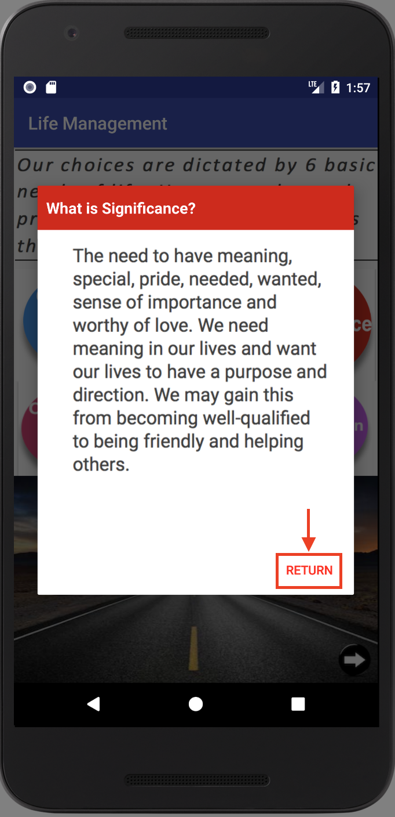

8- Guest clicks on Connection and Love need.

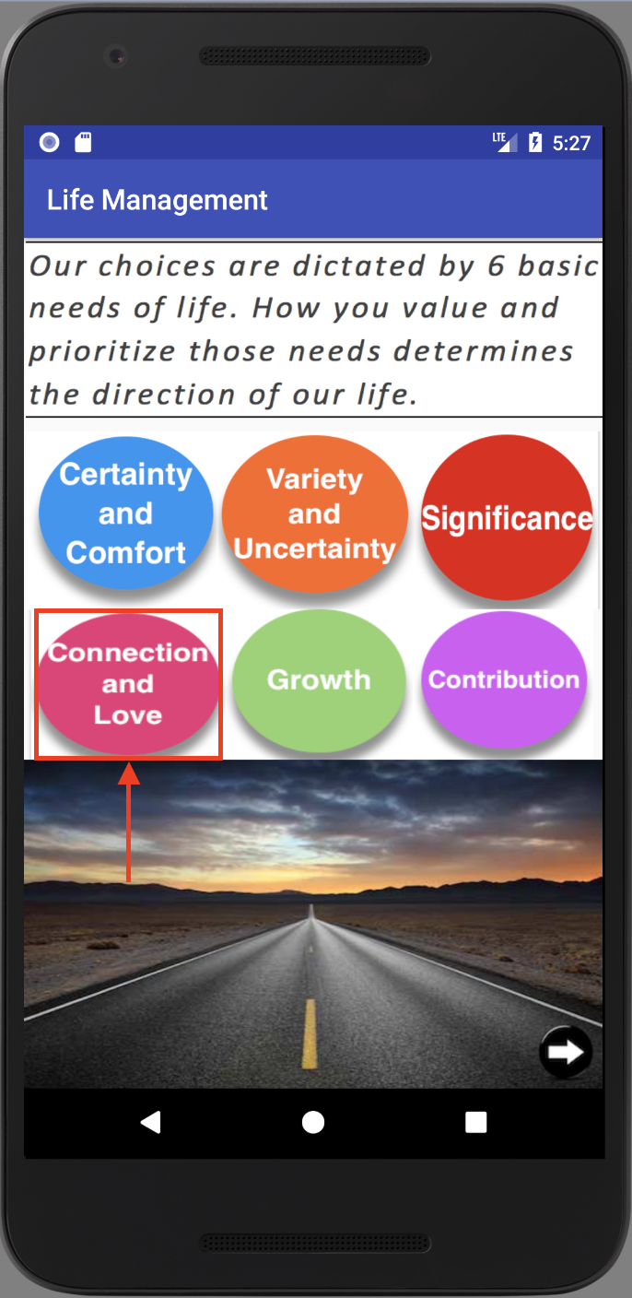

9- After reading that need, they can return to 6 needs screen.

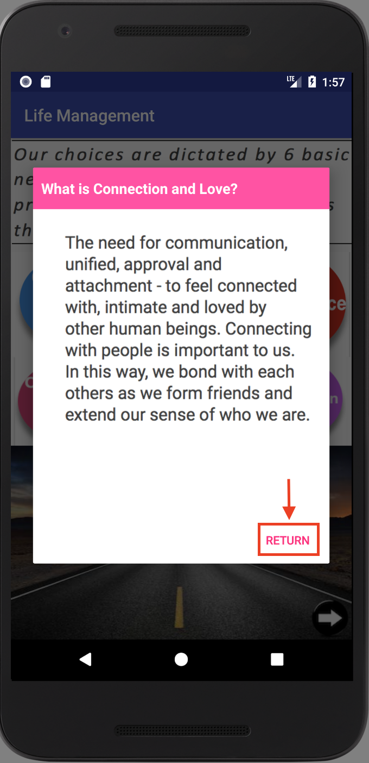

10- Guest clicks on Growth need.

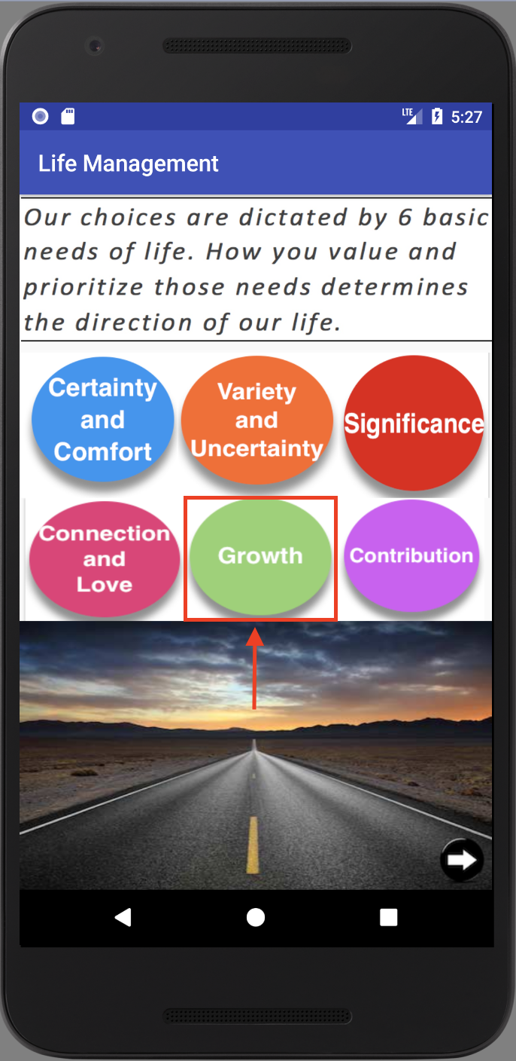

11- After reading that need, they can return to the 6 basic needs screen.

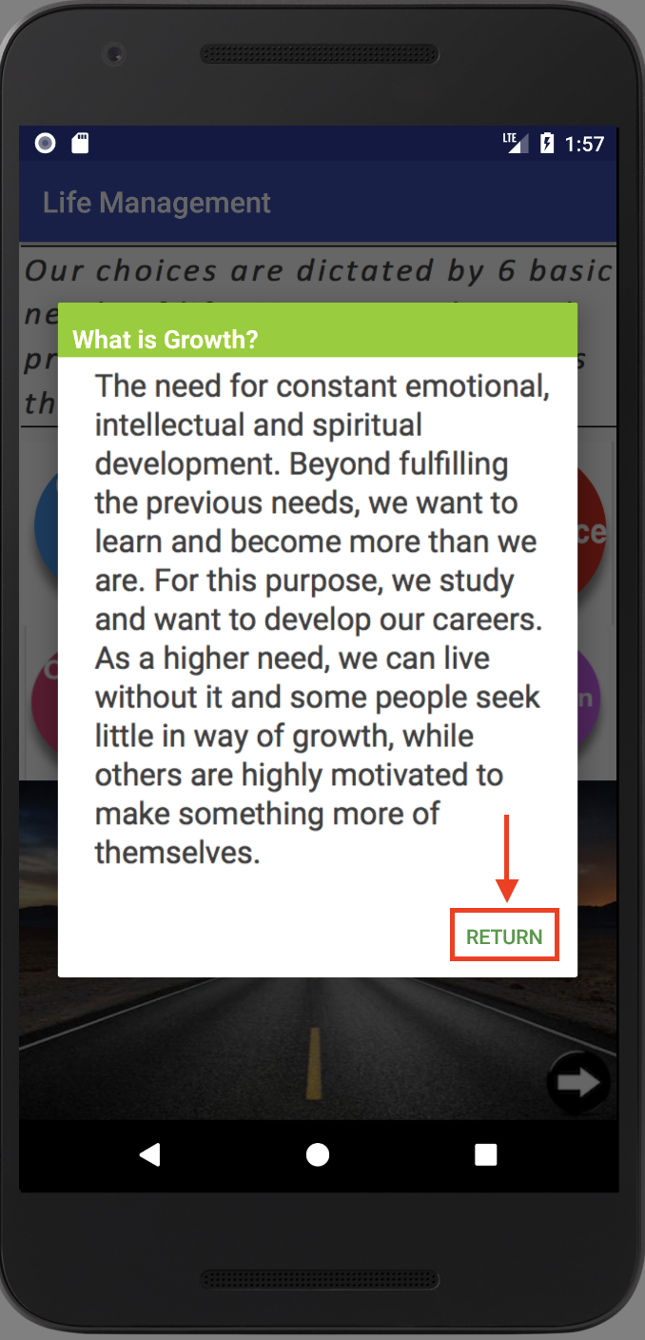

12- Guest clicks on Contribution need.

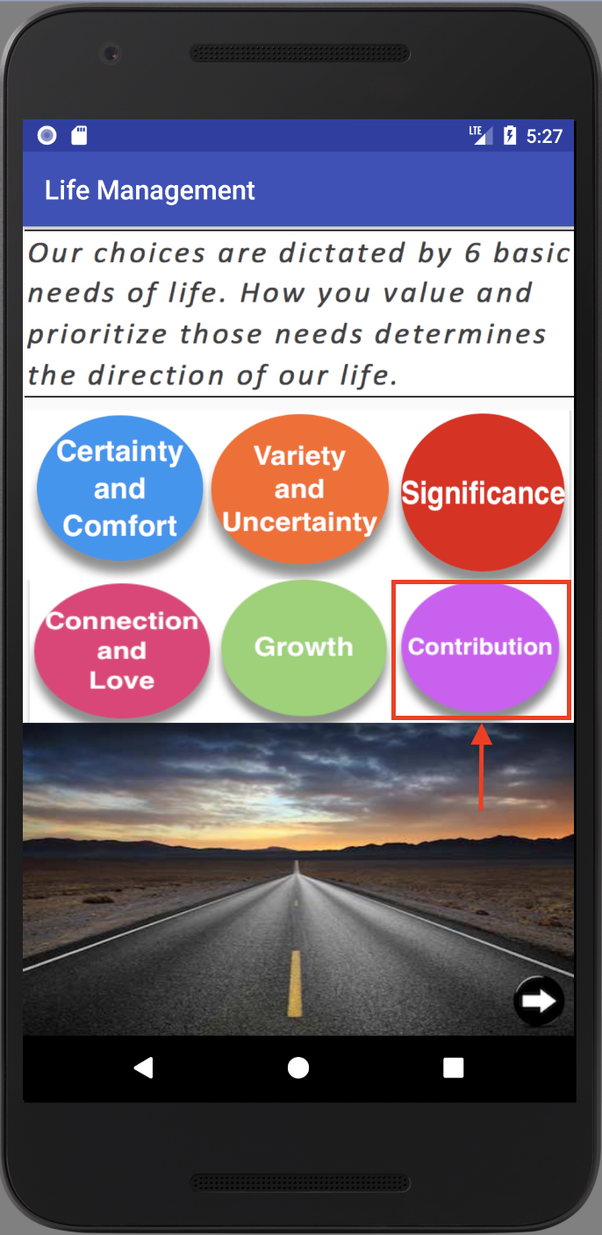

13- After reading that need, they can return to the 6 basic needs screen.

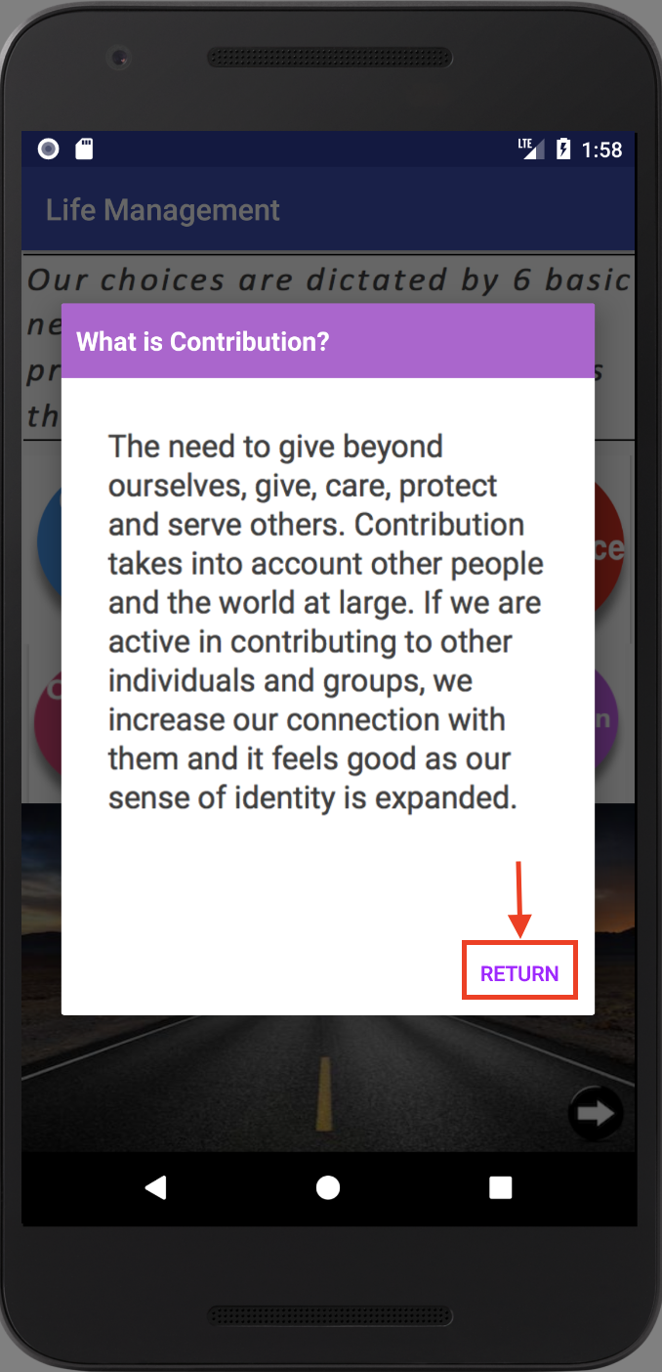

14- Guests can go to next screen

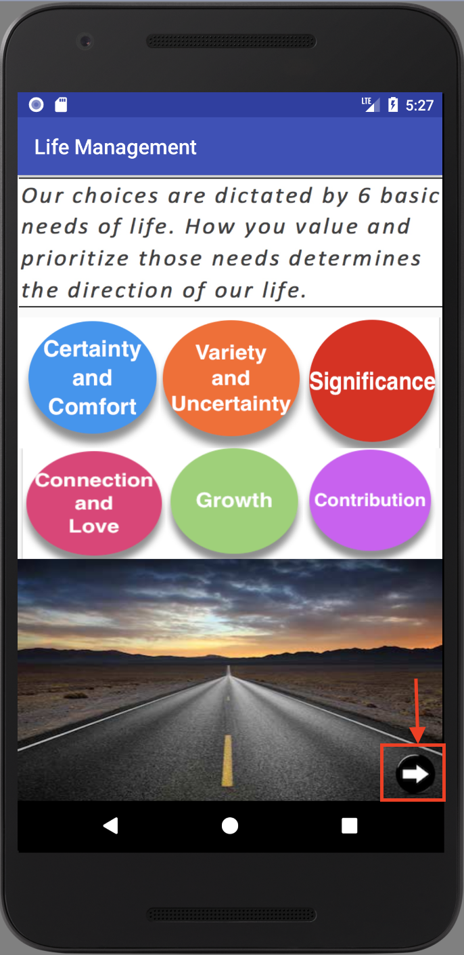

15 - Guest views joy, passion and contribution intro screen and clicks the next arrow to continue to the next page.

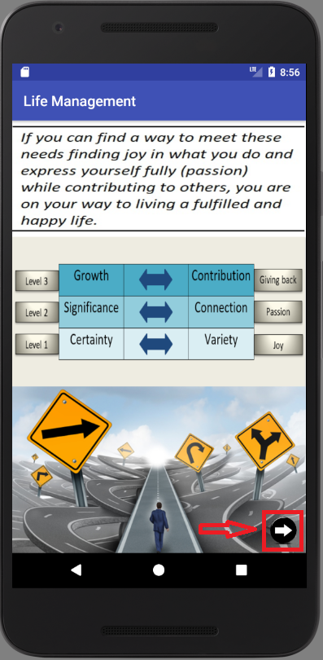

16- Guests can watch an introductory video so they can see the purpose of the app better. After that they can click on the next button to continue to the next page.

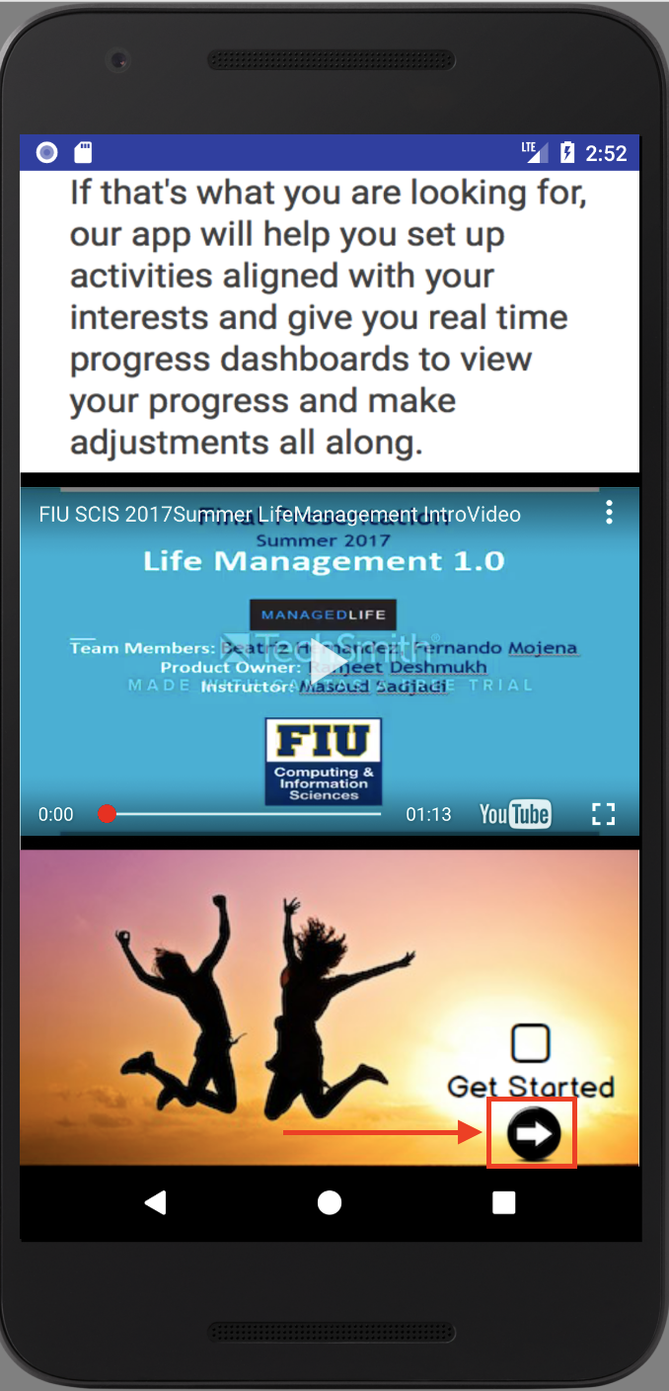

17- Guests can register by clicking on the register button.

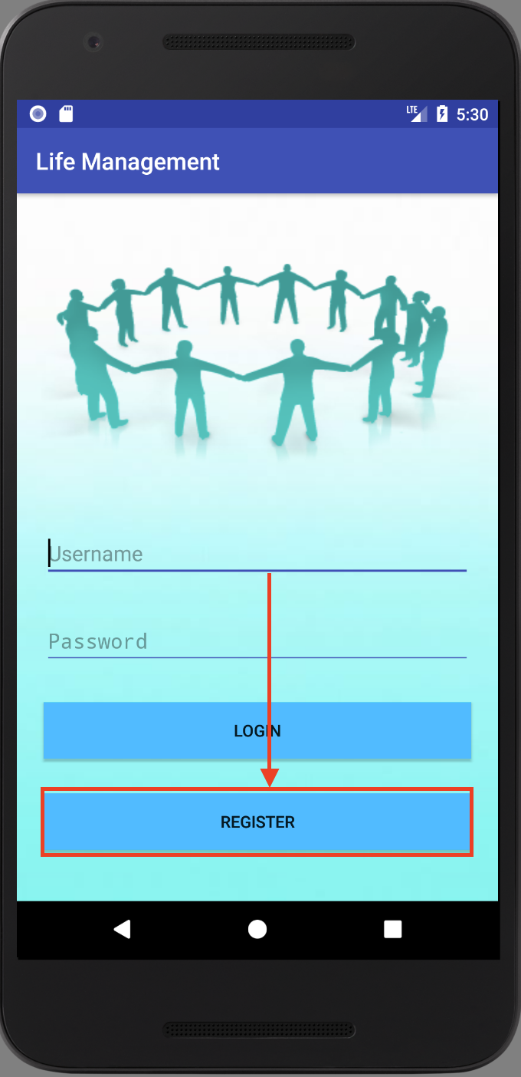

18- Guests provides the following information and click Sign Up.

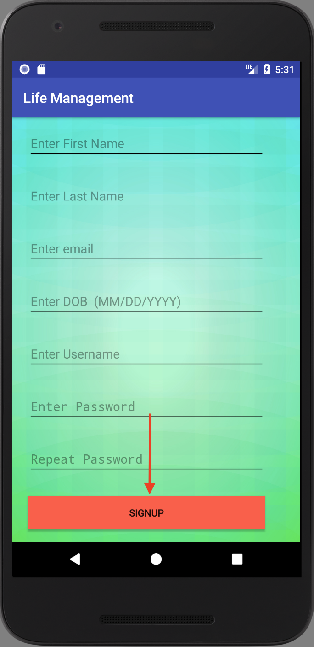

19- Guests select 2 activities for Joy.

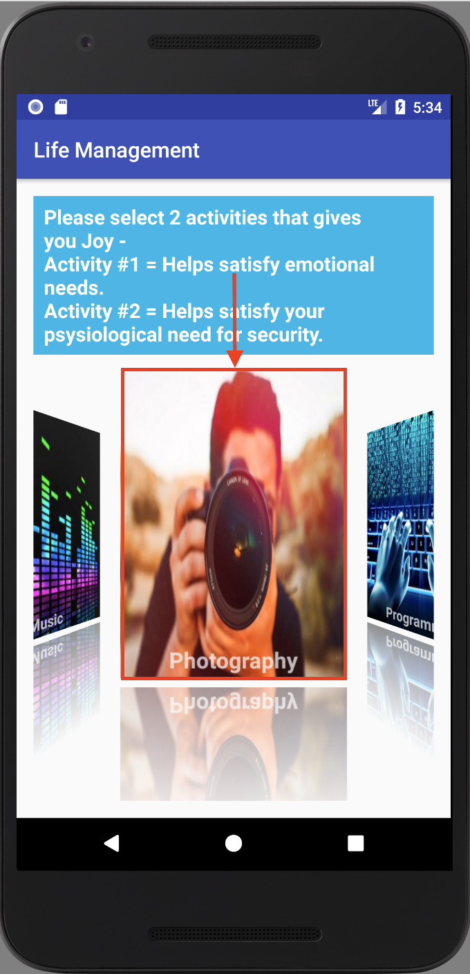

20- Guests confirm the selected activities and go to the next screen.

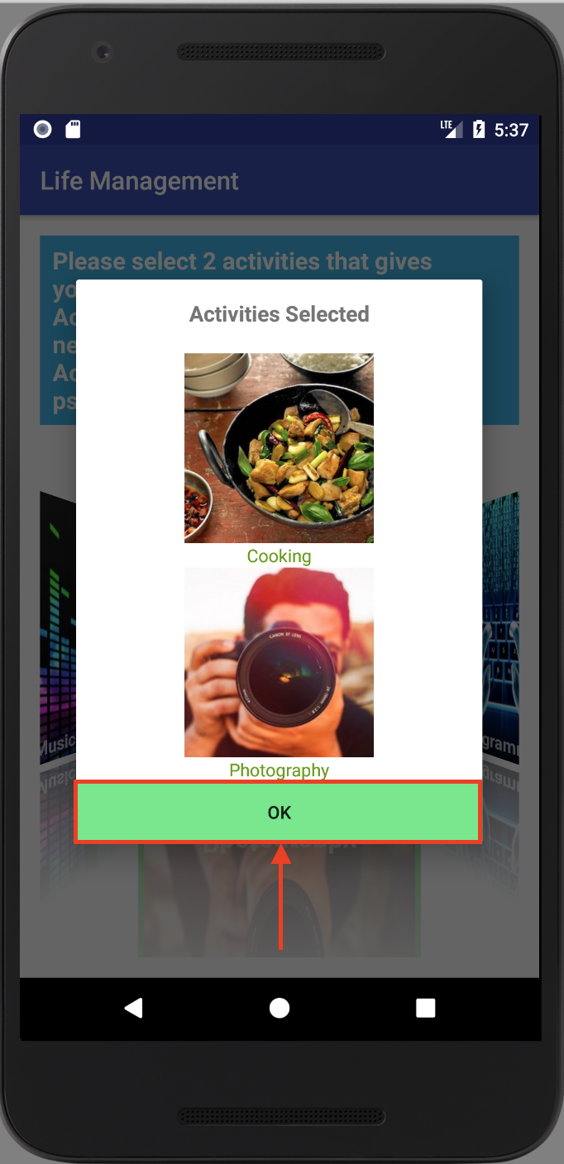

21- Guests select 2 activities for Passion.

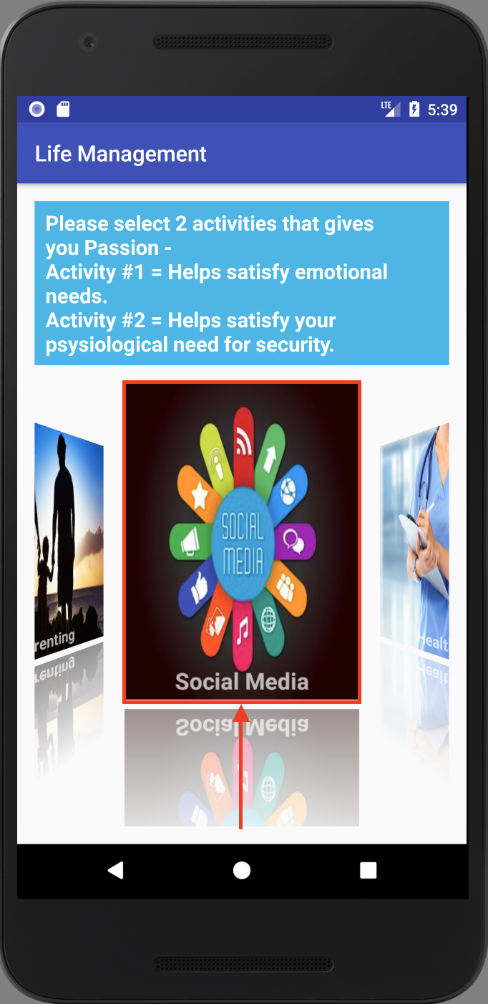

22- Guests confirm the selected activities and click continue.

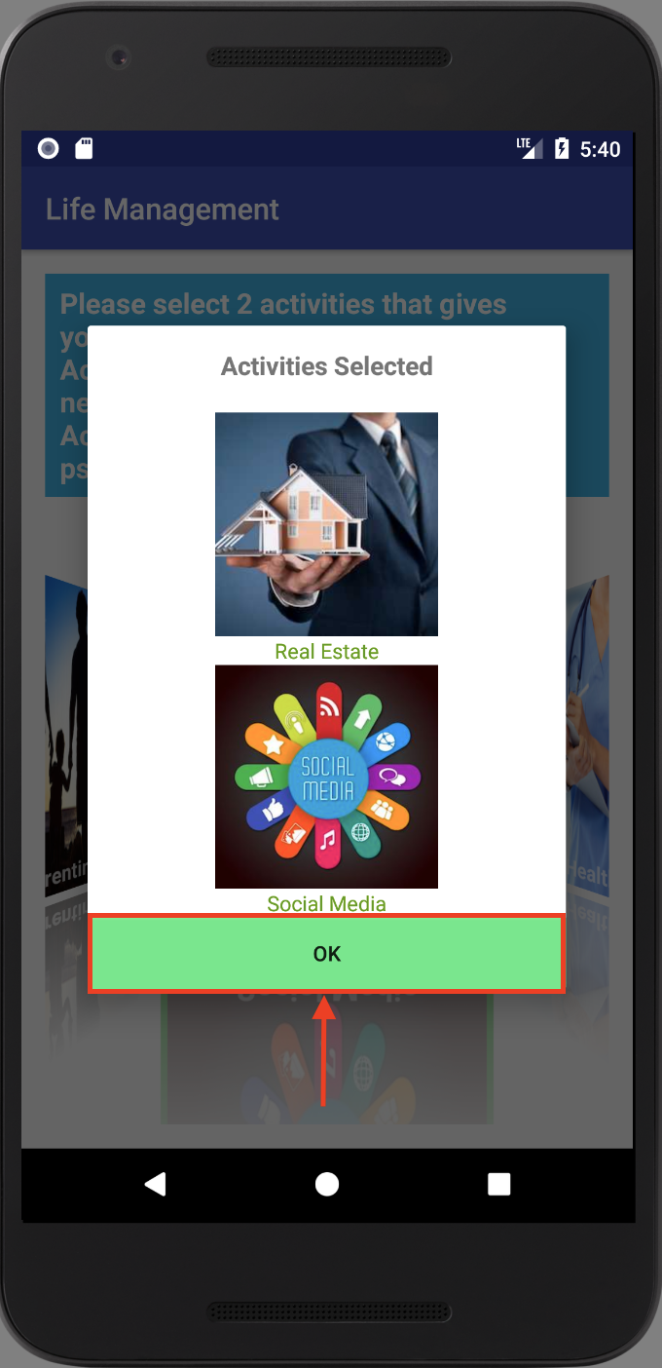

23- Guest selects 2 activities for Contribution by clicking on the image of the activity

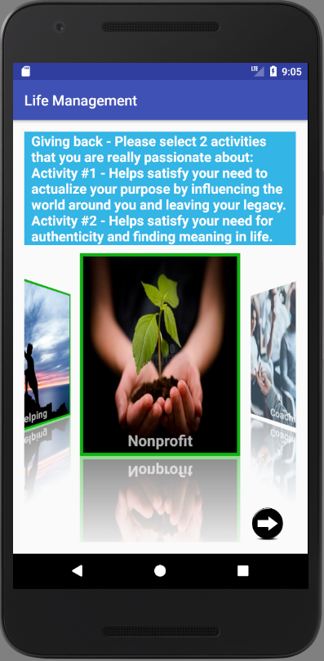

24 - Guest confirms the selected activities and clicks the next arrow to continue.

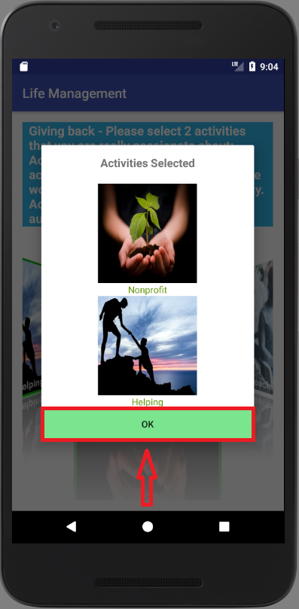

25 - Guest types goal in the sprint goal field

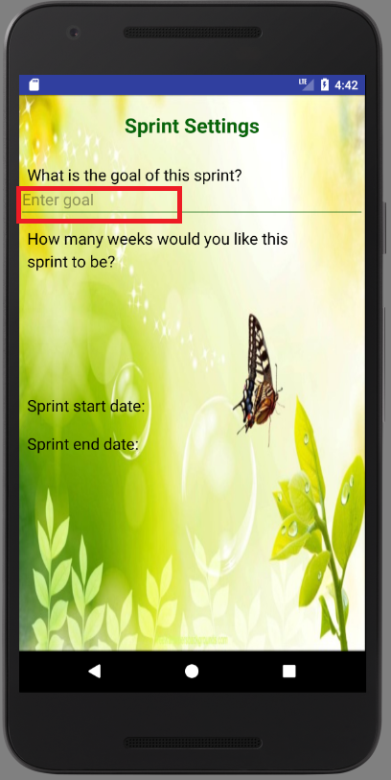

26 - Guest selects sprint duration by clicking on one of the buttons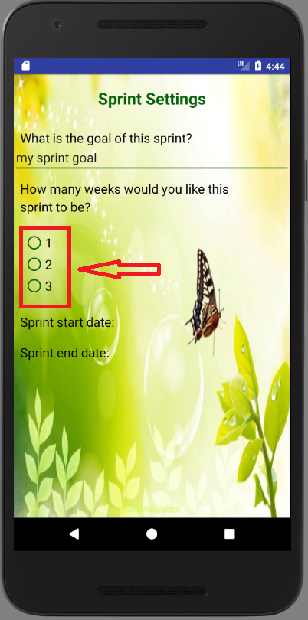

27 - Guest selects sprint start date by clicking on select date text

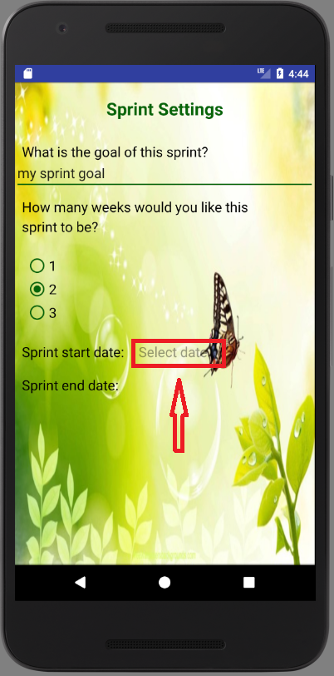

28 - Guest selects start date from the calendar and confirms it by clicking OK

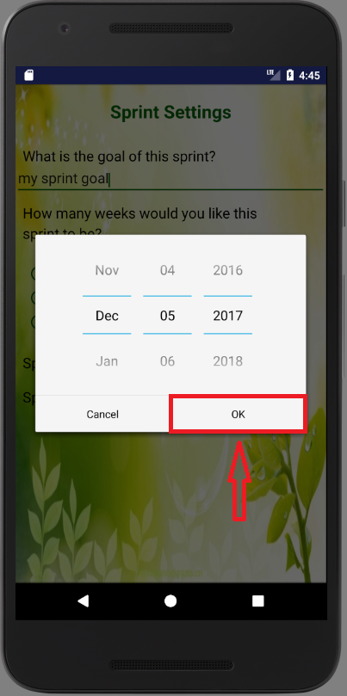

29 - Guest selects sprint end date by clicking on select date text

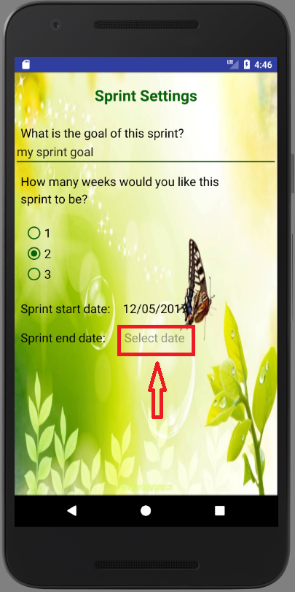

30 - Guest selects end date from the calendar and confirms it by clicking OK

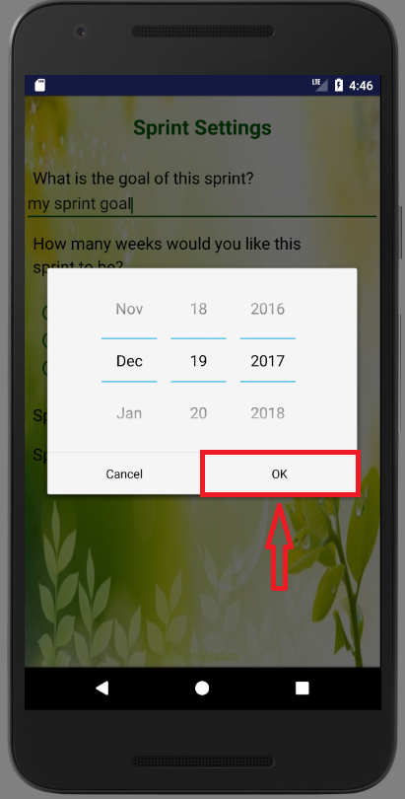

31 - Guest swipes to the next page to continue setting up new sprint

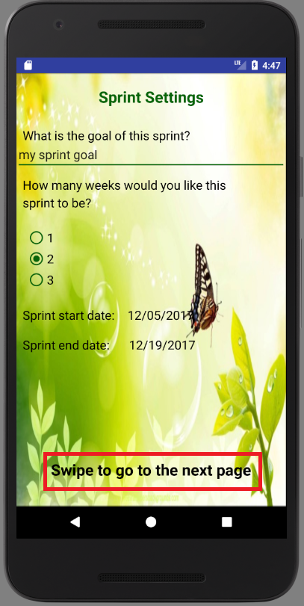

32 - Guest fills out all the fields for activities’ goals and clicks on Submit Sprint Settings button to save new sprint settings

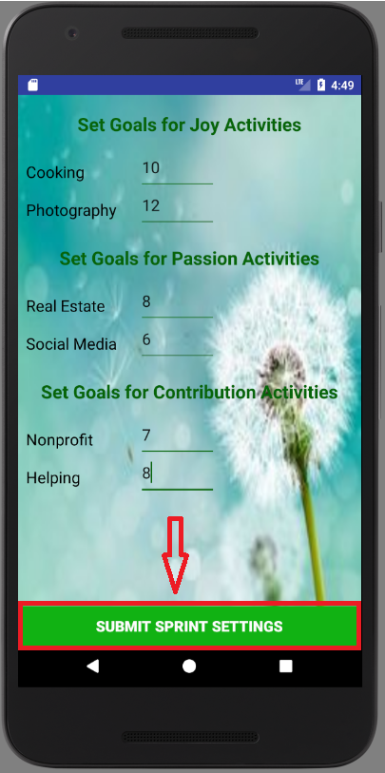

**User**

**Sign in**

User can sign in by entering his/her credentials and clicking on Login button

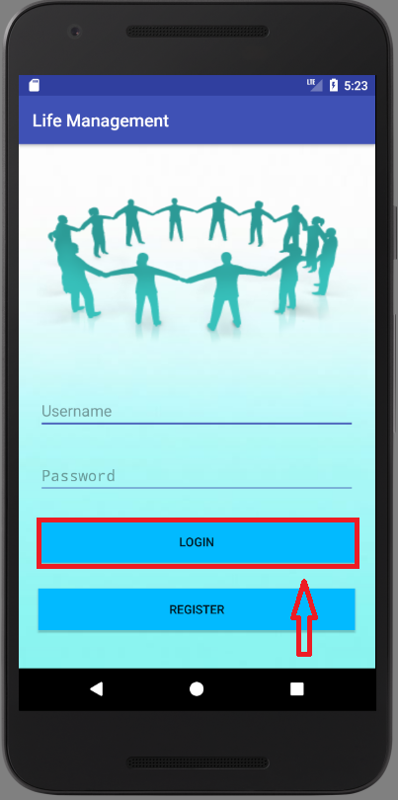

**View user’s dashboard**

Upon signing into the application, user is redirected to his/her dashboard where user can view and update his/her progress for the current sprint.

1 - User can switch between Joy, Passion and Contribution categories by clicking on the corresponding tab on the bottom of the page

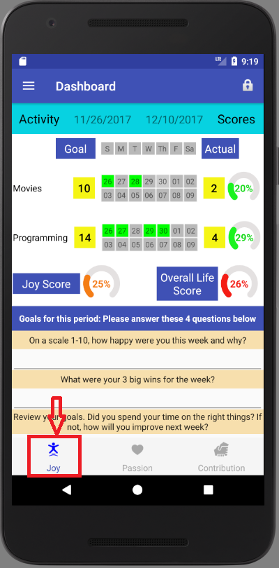

2 - User can update his/her progress for the activity by clicking on one of the buttons corresponding to the calendar day when activity was performed. Green button means that user performed the activity on that day, while grey button means that user did not perform the activity on that day.

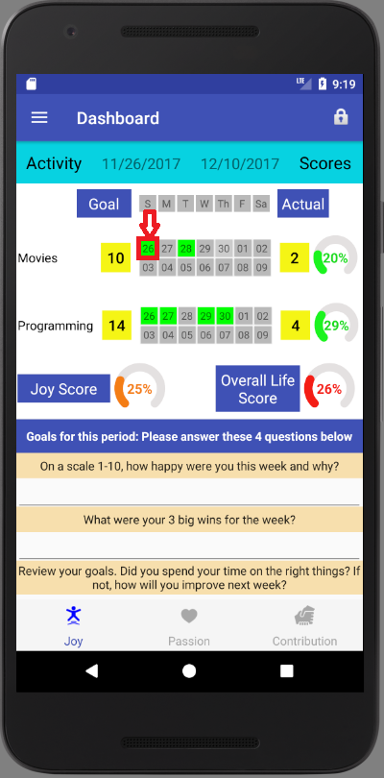

3 - User can see his/her progress for the activity as actual score as well as in percentage. By clicking on one of the buttons corresponding to the calendar day when activity was performed increases activity’s score.

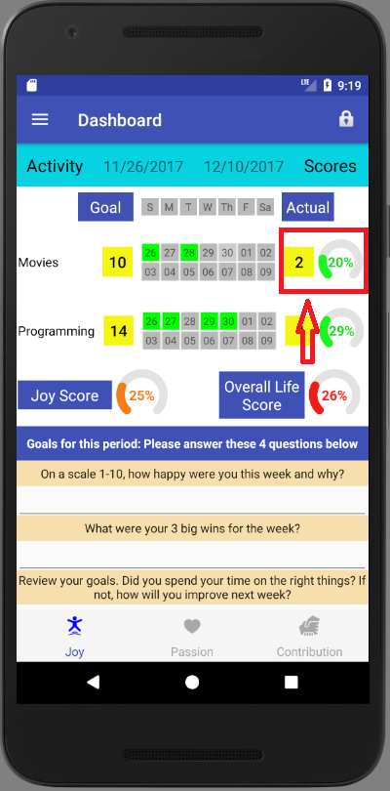

4 - User can see his/her progress for the category in percentage. By clicking on one of the buttons corresponding to the calendar day when activity was performed increases category’s score.

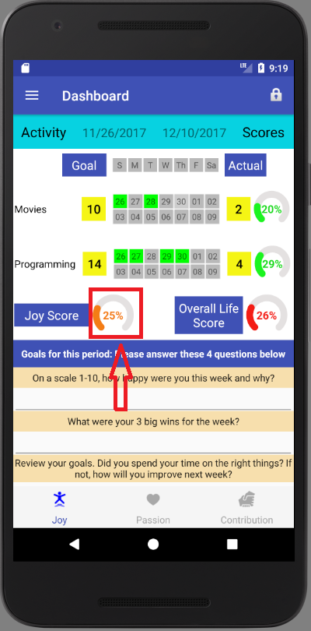

5 - User can see his/her overall life score in percentage. By clicking on one of the buttons corresponding to the calendar day when activity was performed increases overall life score.

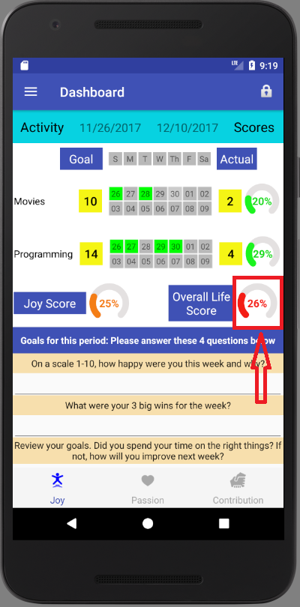

6 - User can update his/her goals for the current sprint period by answering the questionnaire and clicking on Submit Goals button.

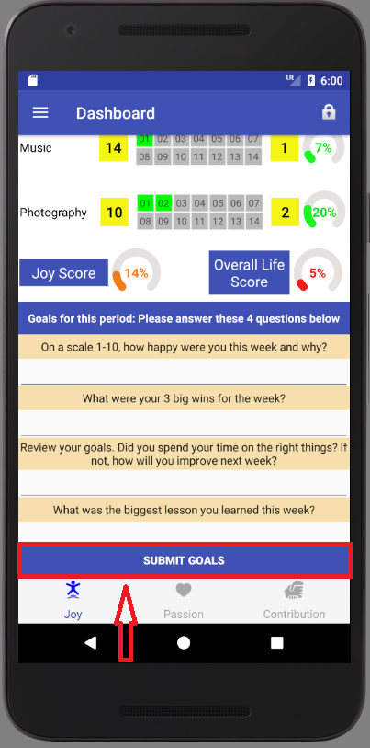

**Start new cycle**

1- User can start new cycle by clicking on the drop-down menu in the top left corner

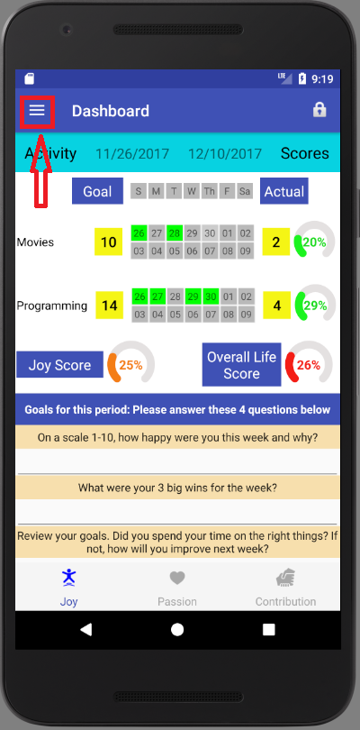

2- User selects New Cycle option by clicking on it from the drop-down menu

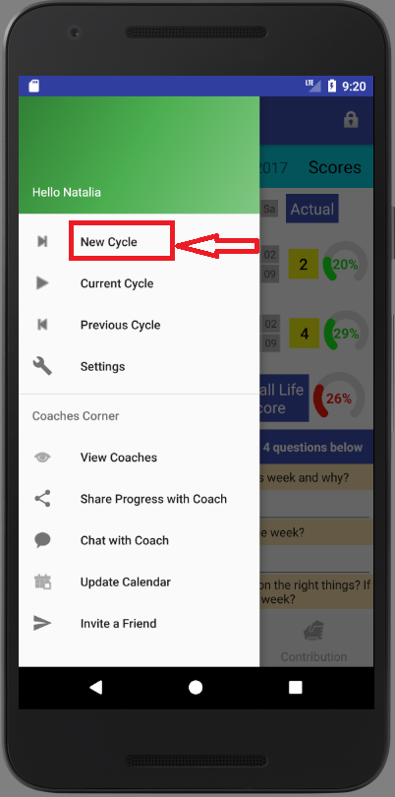

3 - User confirms that he/she wants to start New Cycle by clicking YES, or NO otherwise.

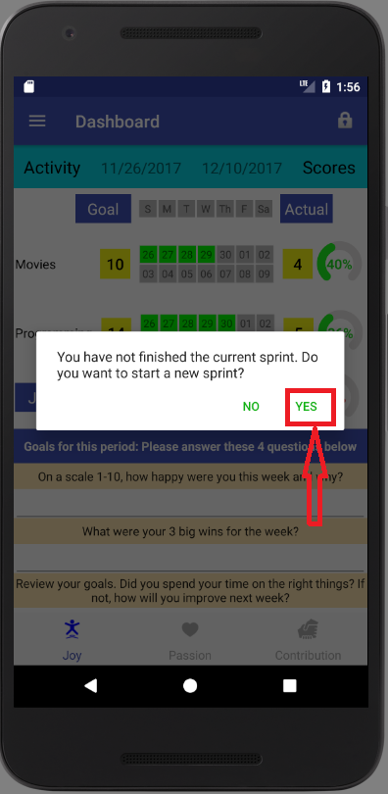

4 - User completes steps 19 - 32 described above in the Guest’s User Manual.

**View Current Cycle**

1- Users can view his/her current cycle by clicking on the Current Cycle button.

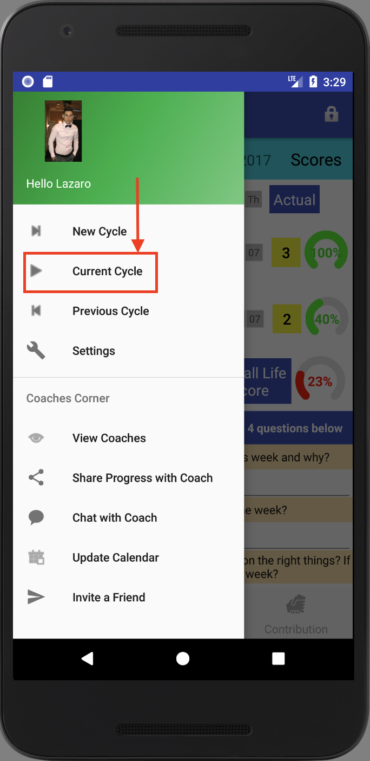

2- Users can go back to Dashboard screen.

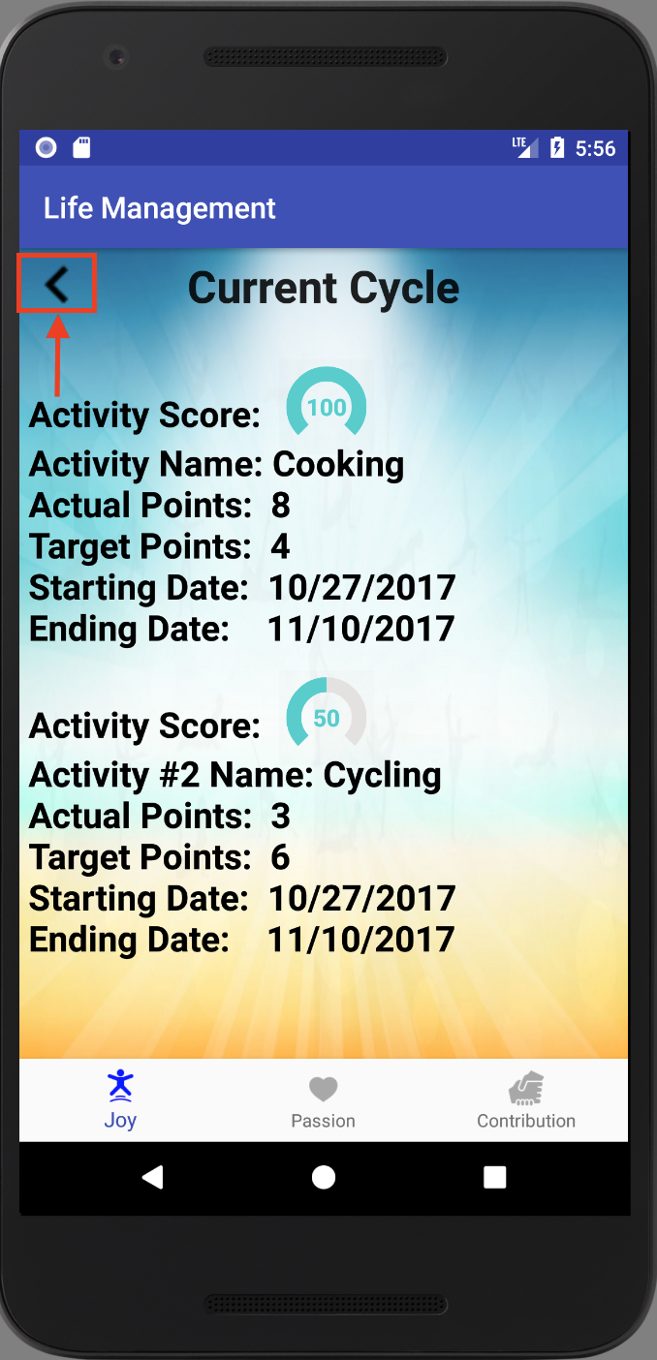

**View Previous Cycle**

1- Users click on the Previous Cycle button

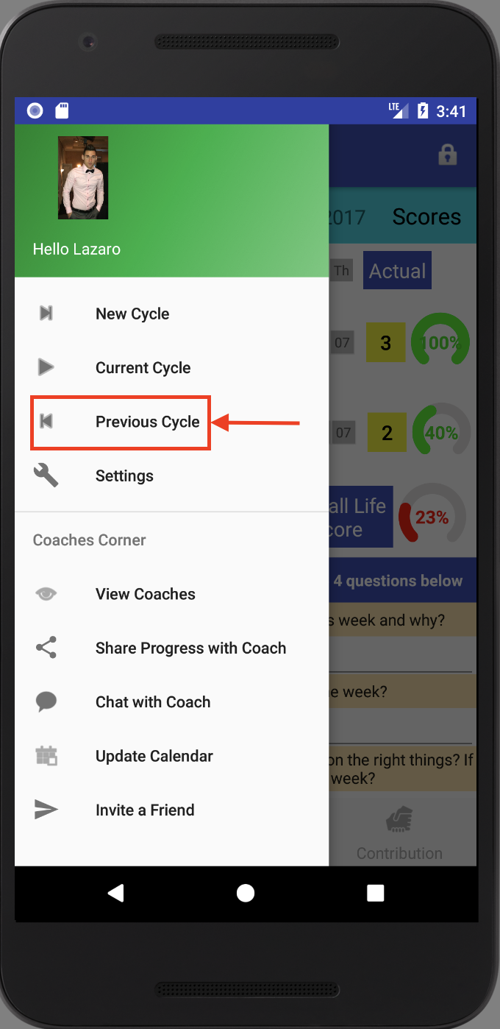

2- Users select any of their previous cycles.

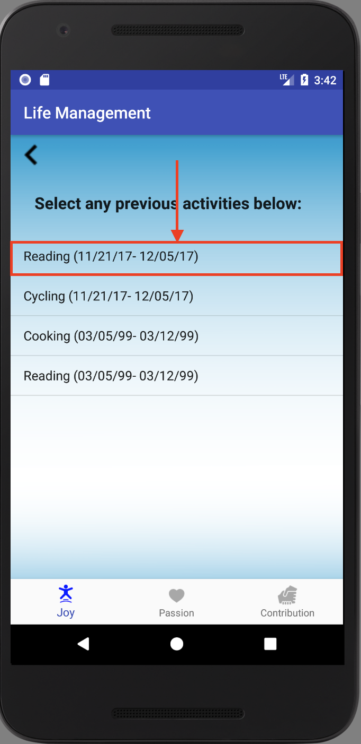

3- Users can view the selected cycle and then can go back.

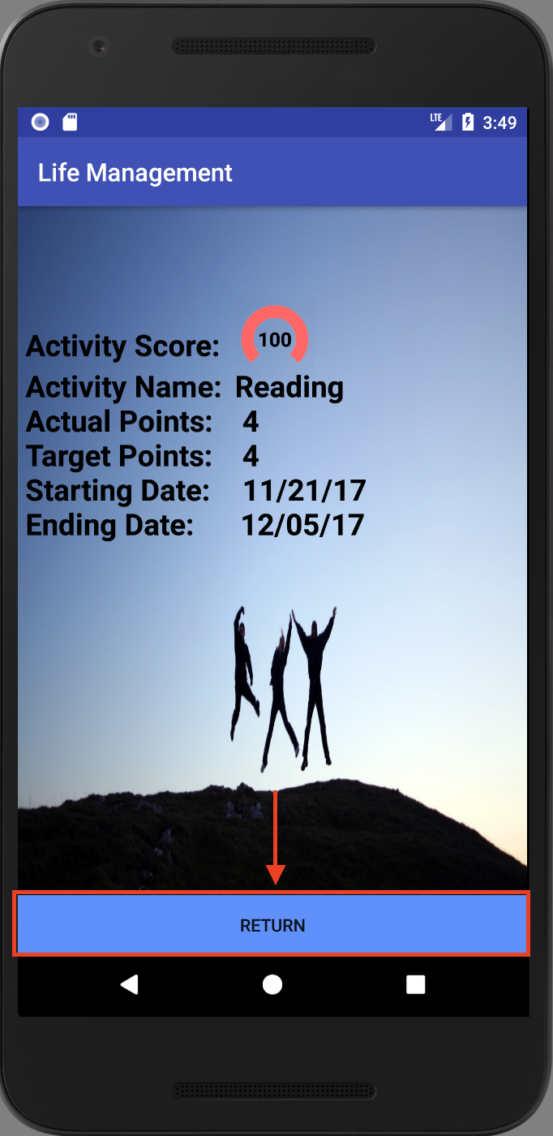

4- Users can return to Dashboard.

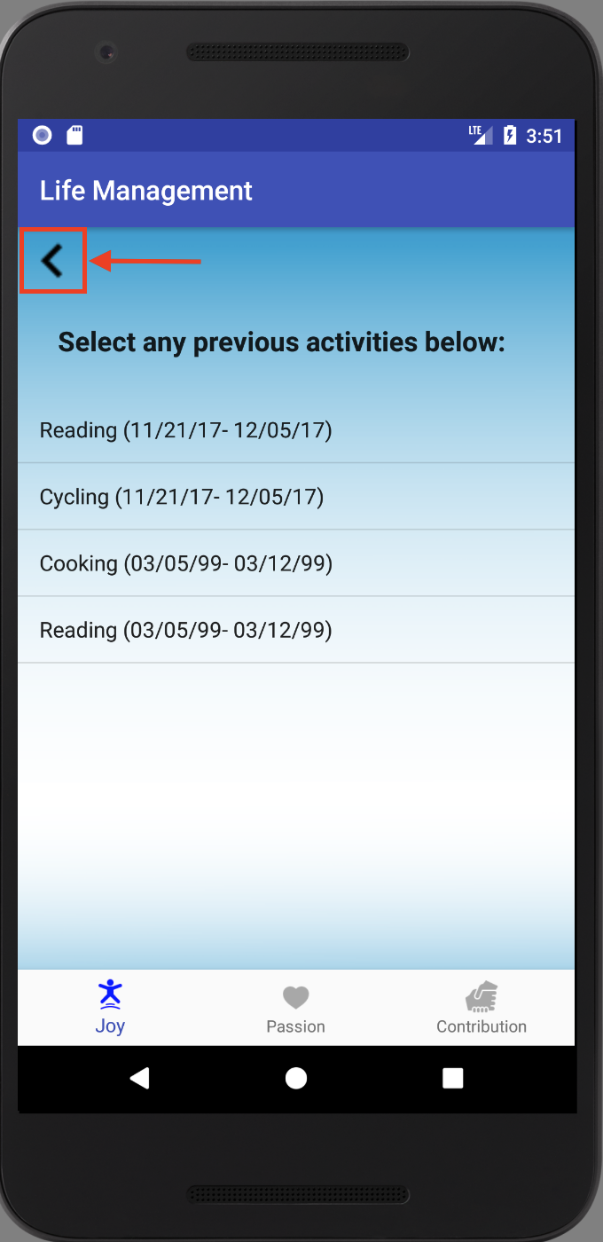

**View Coaches**

1- Users can view current coaches.

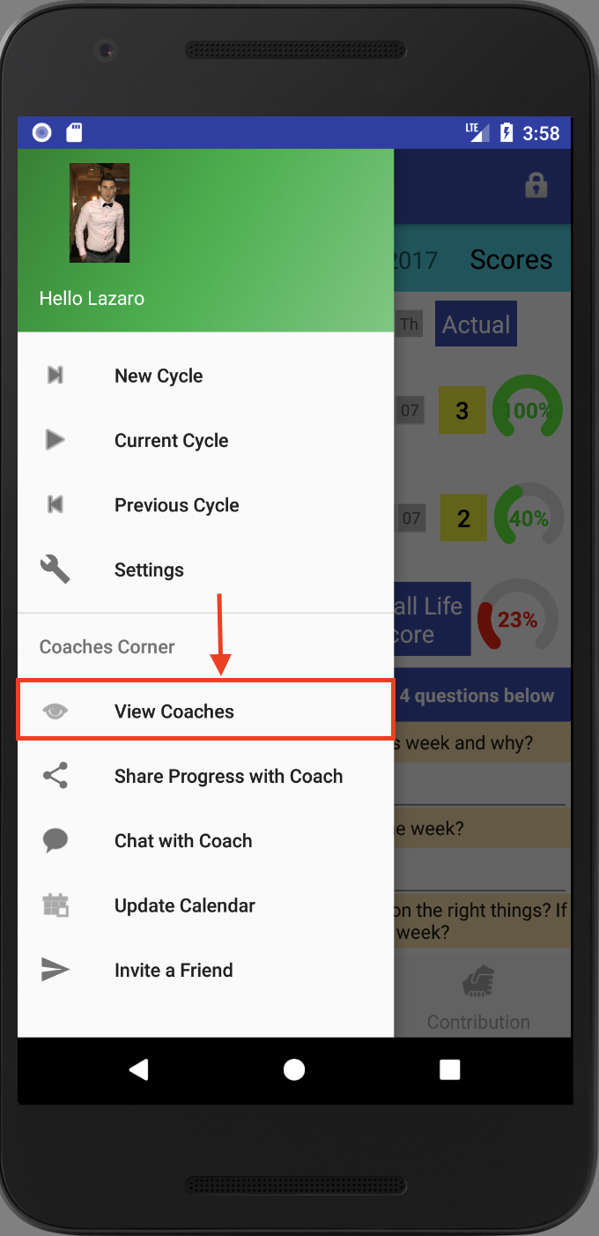

2- Users can return to the Dashboard after seeing the coaches.

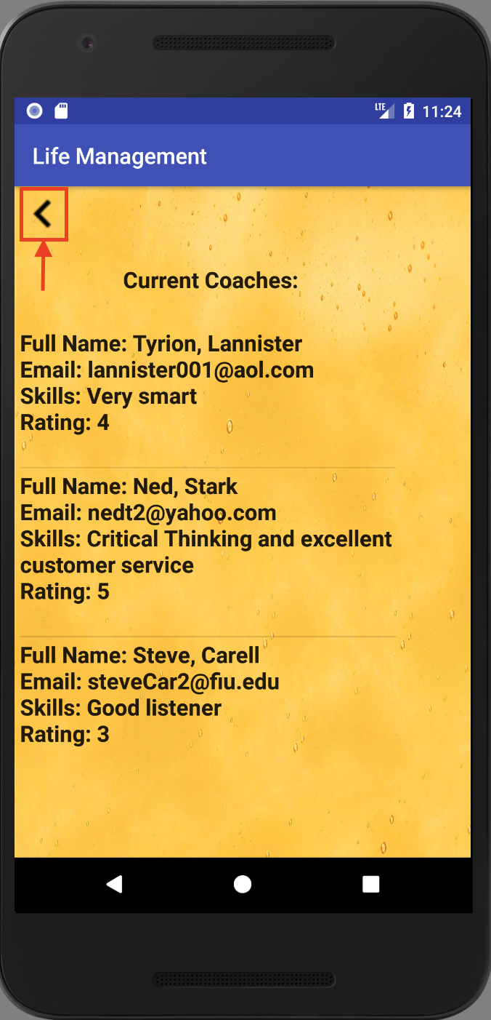

**Chat with Coach**

1 - User can chat with coach by first clicking on the drop-down menu in the top left corner



2 - User selects Chat with Coach option by clicking on it from the drop-down menu

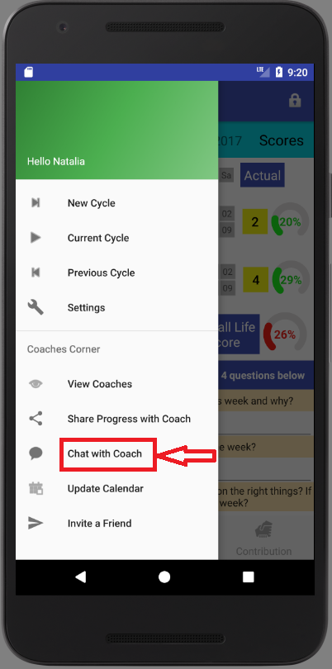

3 - User selects the coach he/she wants to chat with by clicking on coach’s name

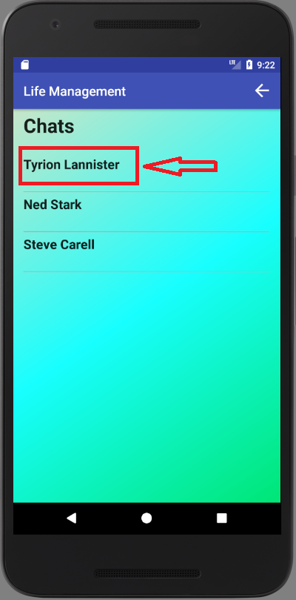

4 - If user would like to go back to the dashboard, user can do so by clicking on the back arrow in the top right corner

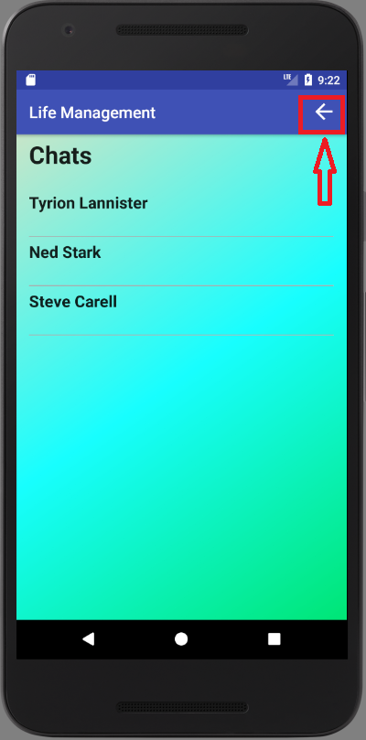

5 - By clicking on the coach’s name user is redirected to the chat page with the selected coach, where user can view history of conversation with that coach by scrolling the page if the previous conversation exists.

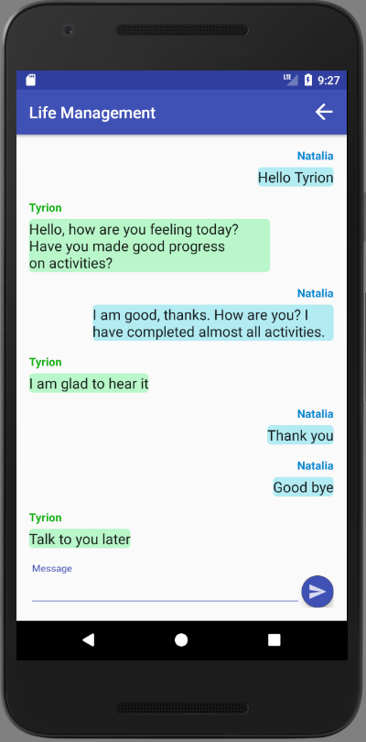

6 - User can send a message to the coach by typing the message in the Message field and clicking on the Send button on the bottom of the page. The user can see the sent message on the bottom of the list of messages.

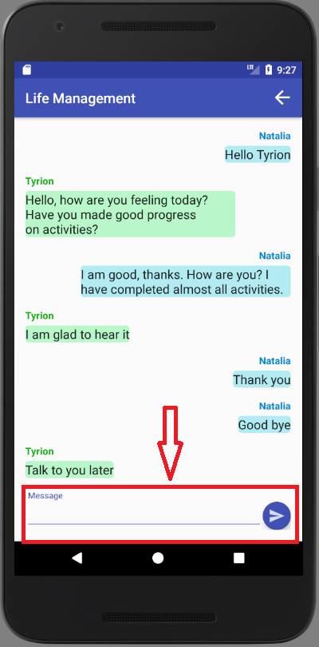

7 - User can return to the previous page to select another coach to chat with by clicking on the back button in the top right corner

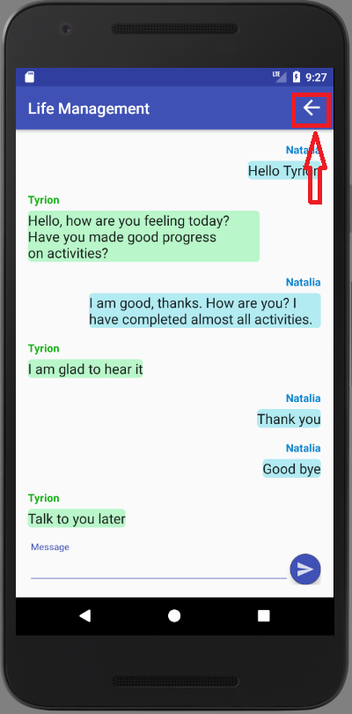

**Sign Out**

1 - User can sign out of the application by clicking on the lock icon in the top right corner of the dashboard

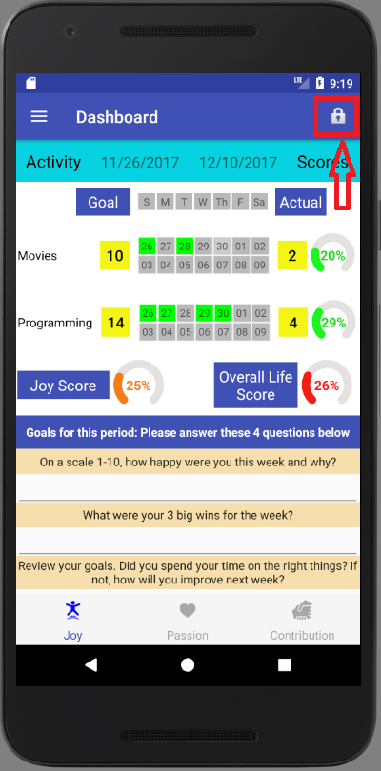

2 - User confirms if he/she wants to sign out by clicking YES, or NO otherwise. If user clicks YES, he/she is redirected to the Login page.

